WORKSHOP INFORMATION / DIRECTIONS

INFORMATION:
Coming Home to the Wisdom of the Body starts at 10:00 am and ends around 6pm. We will start on time, please arrive accordingly.

What to Bring:
Bring a note book, a lunch and any supplement or food you want to test. Lunch can also be purchased in town.
Wear loose, comfortable clothing.

Payment:
Pay with PayPal or mail a check to Dr Alvita Soleil PO Box 491 Hawi, HI 96719

Others:
This is a precious time for you, please turn your cell phone off or leave it in your car.

DIRECTIONS:
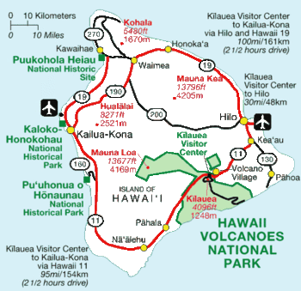

Physical address:
56-2995 Old Coast Guard Road
(808) 889-0770
From Queen Kaahumanu Hwy at Kawaihae intersection

- Turn left toward Kawaihae/Hawi (toward the ocean)
- In about 2 miles you will enter the small harbor town of Kawaihae.
- Turn right at the first intersection and travel approximately 16 miles toward the old Hawaiian town of Hawi.
- As you drive along the beautiful Kohala Coast Road 270, pass Lapakahi, Mahukona and Kapaa
- From Kapaa (exactly 2.8 miles), you will turn left onto Old Coast Guard Rd
- Turn immediately right (no street name)
- Alvita’s house is the last house at the end of the short road
From Waimea from the upper road
- From HPA turn right on the “mountain road”. Travel about 22 miles
- Turn left at the Hawi intersection on Akoni Pule Hwy(gas station on your right)
- Drive 2.4 miles and turn right onto Old Coast Guard Rd
- Turn right at the first road (no street name)
- Alvita’s house is the only house at the end of the short road.
- Park on the grass outside the driveway

For further questions, feel free to contact Alvita Soleil at 889-0770
We are looking forward to seeing you.

